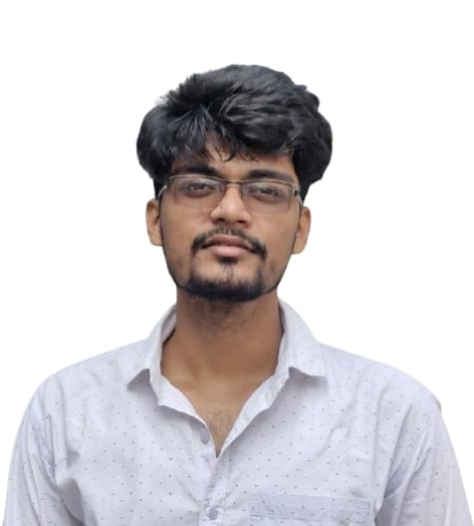**NILADRI BHANDARI**

**Lakshmikantapur, South 24 Parganas , WEST BENGAL – 743336**

**Email: iniladri1408@gmail.com Contact no: 9339440300**

*Pursuing B.Tech in Computer Science with a strong focus on Artificial Intelligence, Machine Learning, and Full-Stack Development. Skilled in Python, cloud technologies, and modern web frameworks, with hands-on experience in deploying AI-powered applications and scalable solutions. Actively engaged in technical internships, projects, and workshops. Eager to contribute to projects, drive organizational success, and continue expanding technical expertise through real-world challenges.*

# EDUCATION

|  |  |  |  |  |
| --- | --- | --- | --- | --- |
| **Name of the Institution** | **Degree** | **Board** | **Year of passing** | **Percentage of Marks** |
| BRAINWARE UNIVERSITY | B.Tech | Affiliated to UGC | 2022-2026 | Average SGPA – 8.44 (Till 6th Semester) |
| MAJILPUR J.M.TRAINING SCHOOL | 12th | WBCHSE | 2022 | 92.2% |
| MAJILPUR J.M.TRAINING SCHOOL | 10th | WBBSE | 2020 | 92.5% |

# SKILLS

* **TECHNICAL SKILLS** 
  + Programming Languages: Python, Java, C, C++
  + Web Technologies: MySQL, HTML, CSS, JavaScript
  + Frameworks/Tools: TensorFlow.js, Flask, Next.js
  + Cloud Platforms: AWS (Exploring), Docker (Exploring)
  + Domains: Machine Learning & AI, Full Stack Dev, DBMS

* **ADDITIONAL SKILLS** 
  + Proficient in MS Office (Word, Excel, PowerPoint).
  + Fluent in English, Bengali, and Hindi.

# INTERNSHIPS

**IBM SkillBuild Internship – AI & Cloud Technologies(July2025 - August 2025)**

AI & Cloud Intern

* Developed and deployed a **cloud-hosted ML prototype** on **IBM Cloud Lite**.
* Gained hands-on exposure to **AI workflows, cloud deployment, and collaborative project execution**.

**Cisco NetAcad Program (August 2025 )**

Network Intern

* Completed modules in **computer networking, switching, and Python programming essentials**.
* Applied networking concepts in **simulated lab environments**.

**The Agnirva Space Internship Programme (April 2025 – May 2025)**

Intern

* Participated in Agnirva Space Internship, Explored the role of **AI in aerospace and satellite data handling**, officially recognized by AICTE.

**Internship on Blockchain & Big Data/Data Science – NIELIT Kolkata(Jun 2025)**

Intern

* Project: “Hadoop File System Management” – focused on HDFS setup, file operations, storage management, and distributed data handling.

# ACADEMIC PROJECTS

• [**Comic Crafter-AI**](https://github.com/Ayak-Here/Comic_generator)

* + Developed AI tool that generates comic backstories and images.
  + Users provide a prompt to create AI-based comic scenes.
  + Combines NLP and image generation for storytelling purposes.
* **Eco-Lifestyle-Agent-AI**
  + Developed a Developed an AI agent that recommends eco-friendly lifestyle changes based on user inputs
  + Integrated interactive features for **user engagement and recommendations**, showcasing sustainability-focused AI applications.
* **Health Care Website**
  + Built a website for medical equipment supplies
  + Using **HTML, CSS, PHP, and MySQL**.
* **WhatsApp-Driven Google Drive Assistant**
  + Created an **automation tool** to manage Google Drive using **WhatsApp commands**.
  + Enabled **file uploads, retrieval, and organization** through a simple chat interface.
* **Networking Simulation & Optimization Tool**
  + Designed a **network topology tool** to automatically generate hierarchical structures from router configuration files.
  + Implemented features for **traffic load analysis, link capacity validation, and load balancing recommendations**.

## OTHER ACHIEVEMENTS

* **Deloitte Data Analytics Job Simulation (Forage, 2025)** – Completed practical tasks in **Data Analysis and Forensic Technology**
* **Hackathons** 
  + Participated in university Organized Hackathons
* **Infosys Springboard AI Internship** – Complete Pre-requisite training on **Artificial Intelligence concepts** and applications.
* Built an **Ecourt Case Tracker** as part of an internship assignment—a Flask-based web app that:

Scrapes real-time case information (parties, status, judge, hearing dates) from the South 24 Parganas District Court site.

## TRAININGS AND WORKSHOPS

* **Industrial Training** with Intel Unnati program.
* **Industry Visit** to Euphoria GenX.
* Attended **5 days workshop** on **emerging trends.**
* Attended **R programming Workshop** organized by our University.
* Completed **Bootcamp on Blockchain** – **NIELIT Kolkata**, FutureSkills PRIME
* Completed **Bootcamp on Big Data & Data Science** – **NIELIT Kolkata**, FutureSkills PRIME

## CERTIFICATIONS

* Completed **C , Python 3.4.3 , Java ,** and **PHP** and **MySQL** training organized at **Brainware University.**
* Completed and certified ininstructor-led **CCNA-1, CCNA-2, CCNA-3** courses **and** self-paced courses**: Cybersecurity, Python Essentials 1 & Python Essentials 2** through **Cisco Networking Academy.**
* Received Certificate of Completion for  **Retrieval-Augmented Generation (RAG)** and **Artificial Intelligence** projects under the **IBM** **SkillBuild Program**. cloud concepts, services, and deployment models.

## EXTRA-CURRICULAR ACTIVITIES

* **Member** of **Tech Club, Brainware University** (April 2024 – Present)
* **Member,** College Fest Organizing Committee (April 2024 – June 2024)
* **Volunteer** & **Publicity Team Member, ICCRET 2K25** (February 2025)
* Additionaly, Organized various campus events like **Teachers’ Day**, **Farewell**, **Freshers** and more.
* Have undergone 5 years of Art & Drawing in Pracheen Kalakendra.
* Member of Institute of Company Secretary(ICSI)

**PROFILES**

[**Linkedin Profil**](http://www.linkedin.com/in/niladri-bhandari)

[**e**](https://www.linkedin.com/in/ayak-manna/)

[**Credly**](https://www.credly.com/users/niladri-bhandari) **Profile**

[**Github Profil**](https://github.com/Niladri-Peace)

[**e**](https://github.com/Ayak-Here)

